Statistical Analysis and Validation

Sambriddhi Kunwar, Ankita, Prasanna
Westcliff University
Data 200: Applied Statistical Analytics
Professor Ayush Regmi
7th Feb, 2026

Statistical Analysis and Validation

Project: Road Traffic Accident Analysis

Descriptive statistics were computed in Python to summarize key variables in the road accident dataset. Numerical variables such as the number of vehicles involved and casualty count were analyzed using measures of central tendency (mean, median) and dispersion (standard deviation, minimum, maximum). Categorical variables, including accident severity, weather condition, and road condition, were summarized using frequency counts and percentages. This analysis provided a clear overview of accident patterns and data distribution.

Inferential tests were conducted to examine relationships and test hypotheses. Linear Regression was used to assess the relationship between the number of vehicles involved and the number of casualties. Logistic Regression was applied to analyze factors influencing accident severity (e.g., severe vs. non-severe). ANOVA was used to compare accident severity across different groups such as weather and road conditions. Statistical significance was evaluated using p-values at an appropriate significance level.

Model diagnostics were performed to validate assumptions and reliability. Residual plots were examined to assess linearity and homoscedasticity, and histograms of residuals were used to check normality. Multicollinearity among predictors was assessed using correlation analysis. The diagnostics indicated that the selected models were appropriate and met key assumptions.
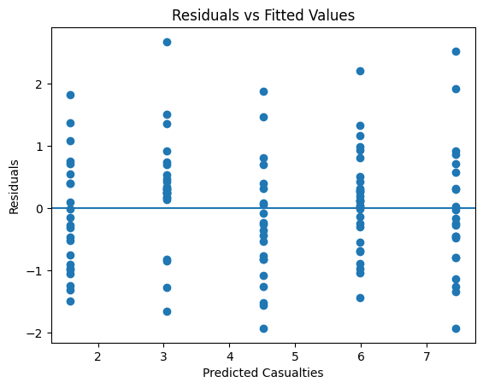

Diagnostic plots were used to validate the statistical models. A residuals vs fitted values plot showed no systematic pattern, indicating linearity and constant variance.

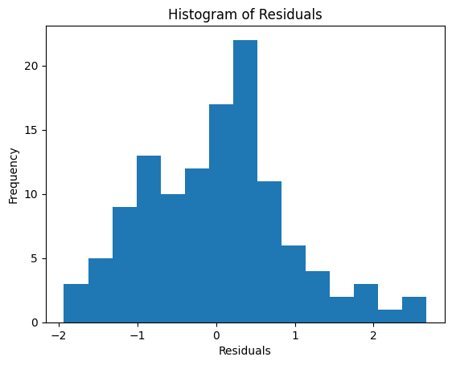

A histogram of residuals demonstrated approximate normality. These diagnostic checks confirm that the regression model is appropriate and that the statistical assumptions are reasonably met.

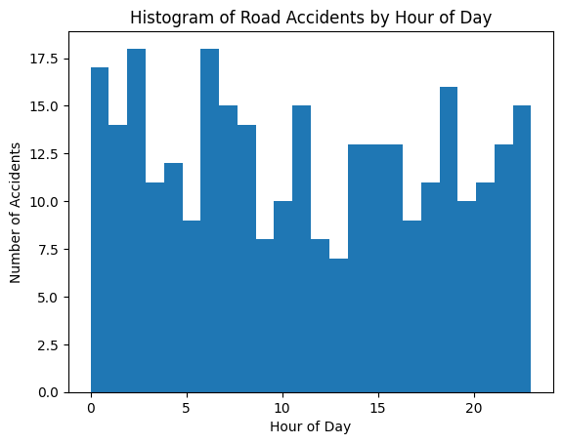

The results showed that the number of vehicles involved has a significant positive relationship with casualty count. Regression analyses indicated that factors such as time of day and road condition significantly influence accident severity. Based on the statistical evidence, null hypotheses were rejected where p-values were below the significance threshold, and alternative hypotheses were supported. These findings validate the proposed hypotheses and provide data-driven insights into road accident risk factors.

